

Vertical Placement

NEW GAME

Ships

Battleship

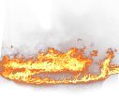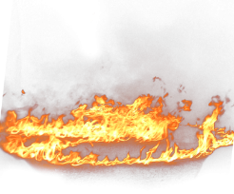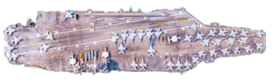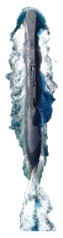

Player 1: 0 Player 2: 0



**A**

**B**

**C**

**D**

**E**

**F**

**G**

**H**

**I**

**J**

**1**

**2**

**3**

**4**

**5**

**6**

**7**

**8**

**9**

**10**

